ELECTRICITY TEST – 2014

Name: SOLUTIONS

50

TIME: 55 minutes

NOTE:

1. Calculations must show clear working with answers stated to three significant figures.

2. Marks will be allocated for clear and logical setting out.

3. State assumptions if working on open ended type questions.

Part 1: Multiple choice (6 marks) Circle the correct response.

1. The electrical resistance of a metal wire is increased by increasing its:  I temperature  II length  III cross-sectional area | (a) I only  - III only  - I and II only  - II and III only  - I, II and III

32. The open-circuit voltage of a 6-V battery is measured as 5 V. When the battery is short-circuited with an ammeter, the ammeter reads 4 A. What is the internal resistance of the battery? | ((a) Not enough information  ((b) 1.5 Ω  ((c) 1.25 Ω  ((d) 1.2 Ω  ((e) 1 Ω

33. How much does it cost to run a 1500 W oven for 3 hours if electricity is charged at 20 c per kW h ? | ((a) $9.00  ((b) $1.00  ((c) $0.90  ((d) $0.60  ((e) $0.10

4. The right and left headlights of a car are connected to the battery as shown below. Which headlight gets more voltage?  right headlight  left headlight  x ampere  5.0 ampere  10 ampere  12 V | - not enough  information  (b) same  (c) right headlight  (d) left headlight

5. What is the power dissipated by an electric light filament of resistance 1.54 ohms if a potential of 10.0 volts DC is maintained across the terminals? | (a) 23.7 watts  (b) 15.4 watts  (c) 64.9 watts  (d) 154 watts

6. Which statement about meters and their correct connection into circuits is TRUE?

- A voltmeter should have a low resistance and be connected in series with a component
- An ammeter should have a high resistance and be connected in parallel with a component
- A voltmeter should have a high resistance and be connected in series with a circuit
- An ammeter should have a low resistance and be connected in series with a component

Part 2: Short answer questions (44 marks)

1. A camera flash gun passes 6 x 10¹² electrons between its electrodes in a time of 1.6 ms. What is the average current flowing during the flash discharge? (2 marks)

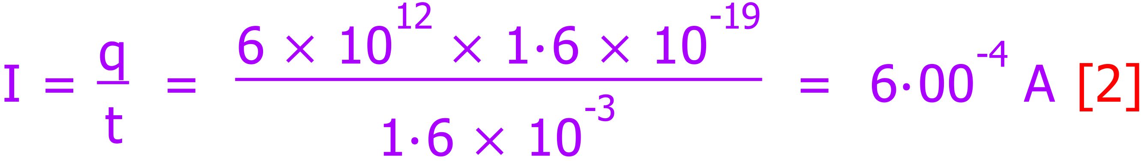

2. Calculate the magnitude and direction (i.e. in or out) of the unknown current I in the figure below (2 marks).

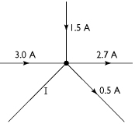 | 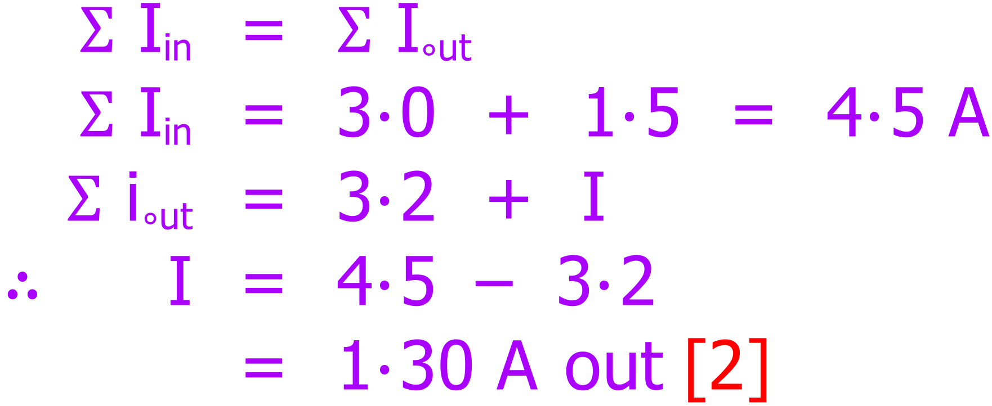

3. The resistance of a wire is given by the equation 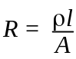 where, R = resistance (Ω), l = length of wire, A = cross sectional area of wire and ρ = the resistivity of the particular material used in the wire.

An electrician uses a particular copper wire in a household circuit which has a resistance of 0.1 Ω. If he exchanges this for another copper with double the length and 4× the cross-sectional area, what will be the resistance of the new wire? (2 marks)

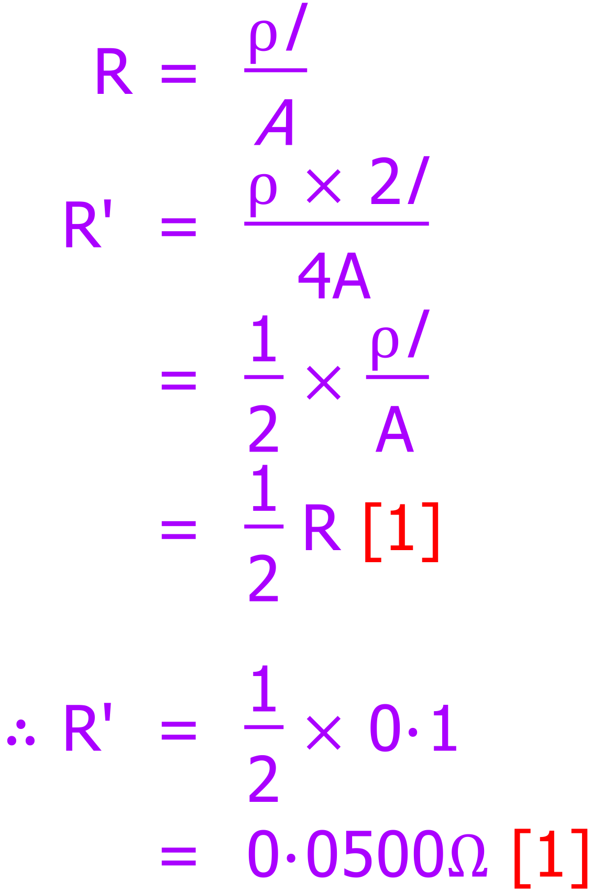

4. An electric kettle is connected to a 240 V supply that draws a current of 8.50 A. Show your working and calculate:

a) The power rating of the kettle. (2 marks)

b) The heat energy produced in 2 ½ minutes. (2 marks)
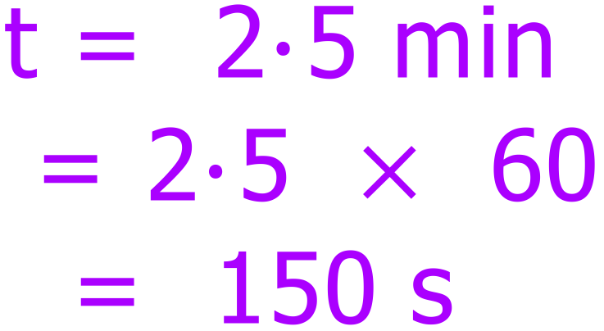

5. A car 12 V lighting diagram shows 6 lamps connected to a common fuse. The lamps, all running from the battery are: 2 x headlights (H), at 42 W each; 2 x rear-lights at 21 W each (R); 2 stoplights at 36 W each (S).
Fuse
H
Metal chassis connection
12 volts
H
R
R

S
S

The owner of the car put a 15 A fuse in the circuit. Is this fuse likely to be appropriate? Show your working and explain your answer. (3 marks)

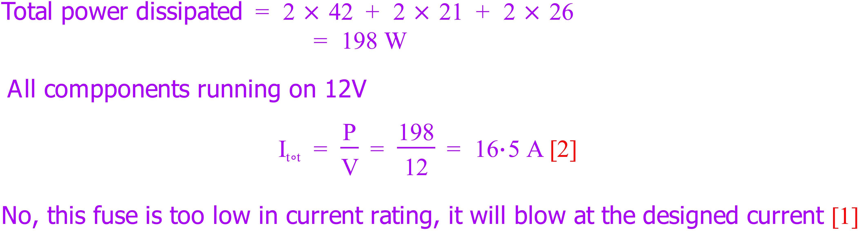

6. If a switch is placed on the neutral wire rather than the active wire in a household electrical circuit the switch is still able to turn devices on and off. However, a switch is placed on the neutral wire is potentially hazardous. Explain why. You may wish to use a diagram. (3 marks)

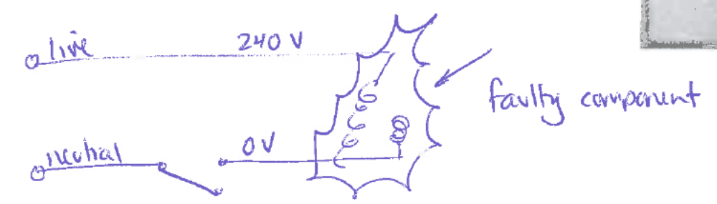

The diagram shows a switch incorrectly placed on the neutral line.
If a component is faulty and it becomes “live”, a switch on the neutral line will not isolate it from the supply voltage and so it will still be dangerous to touch even though it is switched off.

7. The current in the ammeter below is measured as 3 A. Determine the value of the unknown resistance. (4 marks)

12 V
R Ω
5 Ω
A
100 Ω
5 Ω

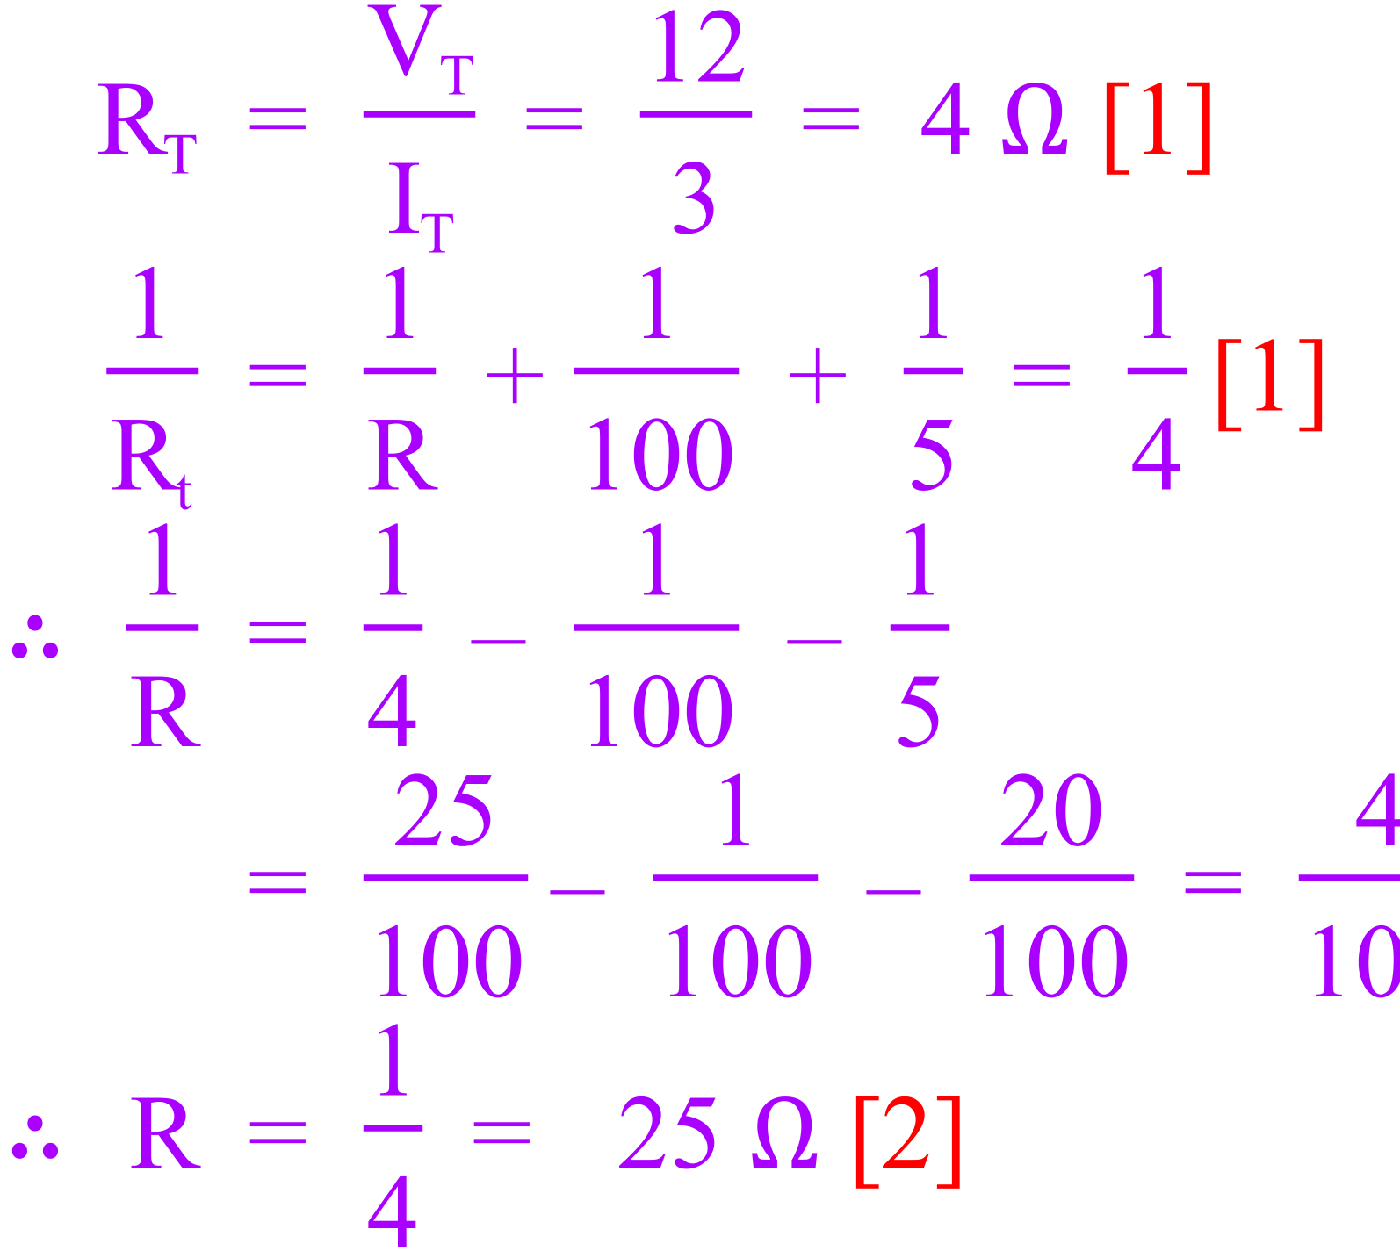

8. A 12.0 volt battery from a certain car has a capacity of 140 Ah, which means that it can supply a current of 140 A for 1.00 hour, a current of 70.0 A for 2.00 hour, and so forth.

(a) How much energy is stored in the battery? (3 marks)

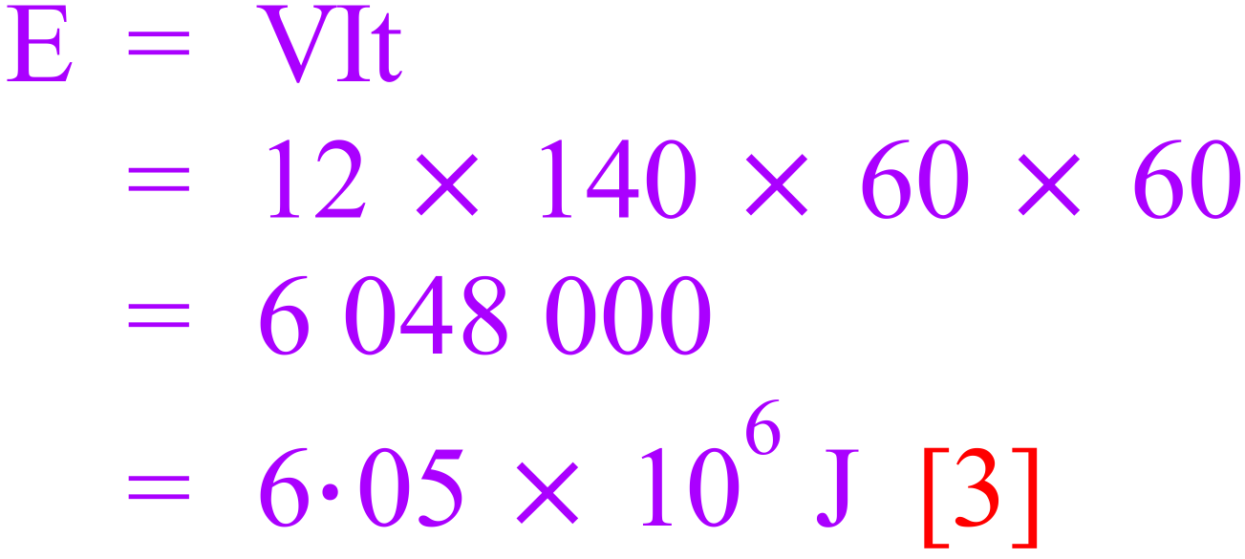

(b) If the car’s lights require 60.0 W of power, how long (in hours) can the battery keep them lighted when the engine (and hence its generator) is not running? (2 marks)

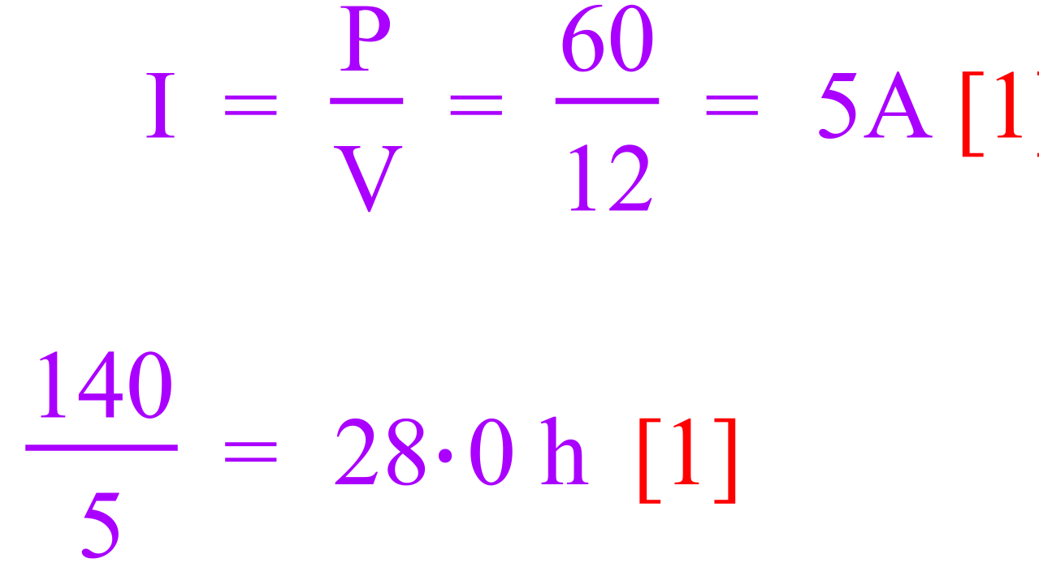

9. The element of an electric jug has a resistance of 50.0 Ω and draws a current of 4 A. 1.3 kg of water at a temperature of 25⁰C is in the jug. How long will it take to bring the water to the boil (100⁰C)? (3 marks)

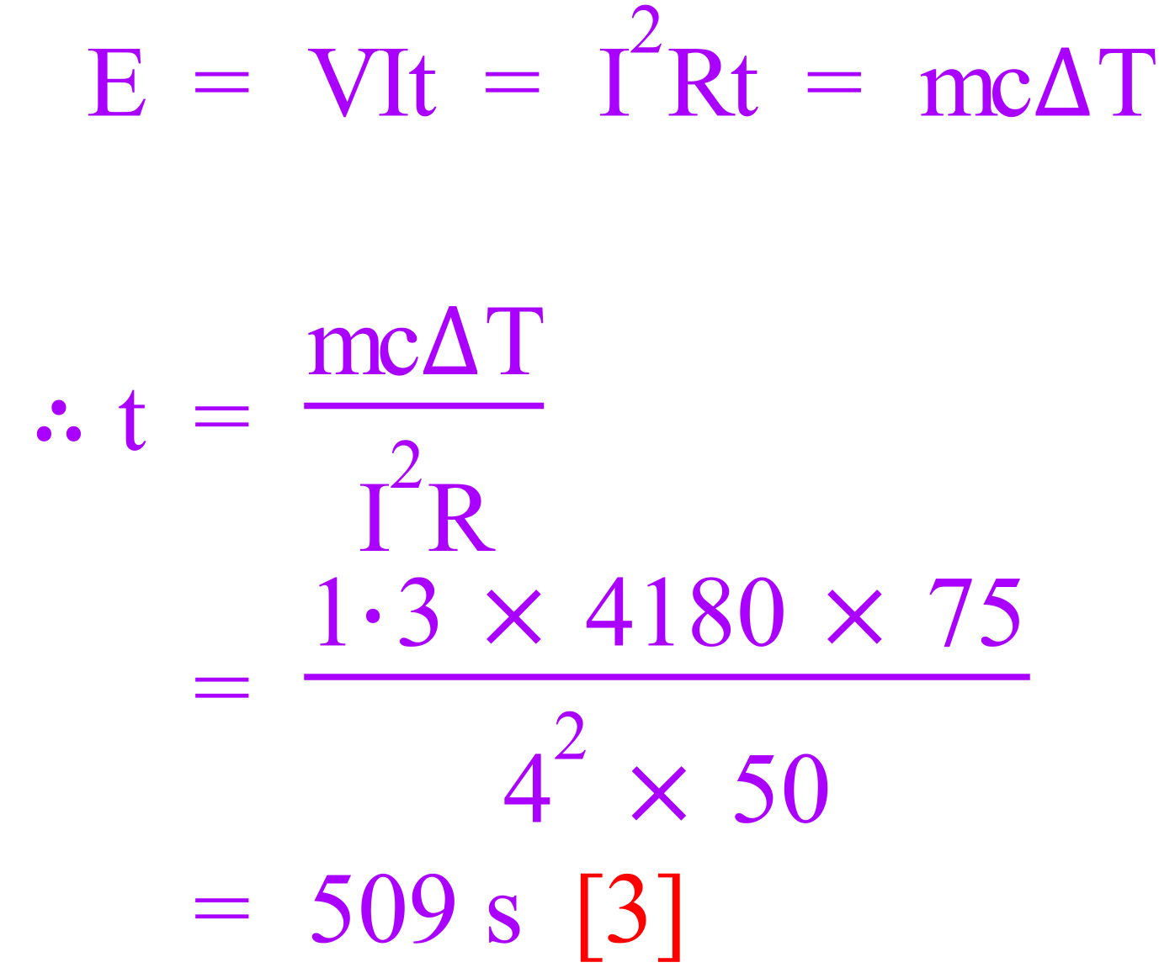

10. Three resistors are connected to a DC power supply as shown. When all switches are closed, it is found that the current in the 5.00 Ω resistor is 500 mA.
R₁ = 5 Ω
R₂ = 15 Ω
S2
S3
S1
R₃ = 30 Ω

(a) With switches S1, S2 and S3 closed, calculate the total resistance of the circuit. (2 marks)

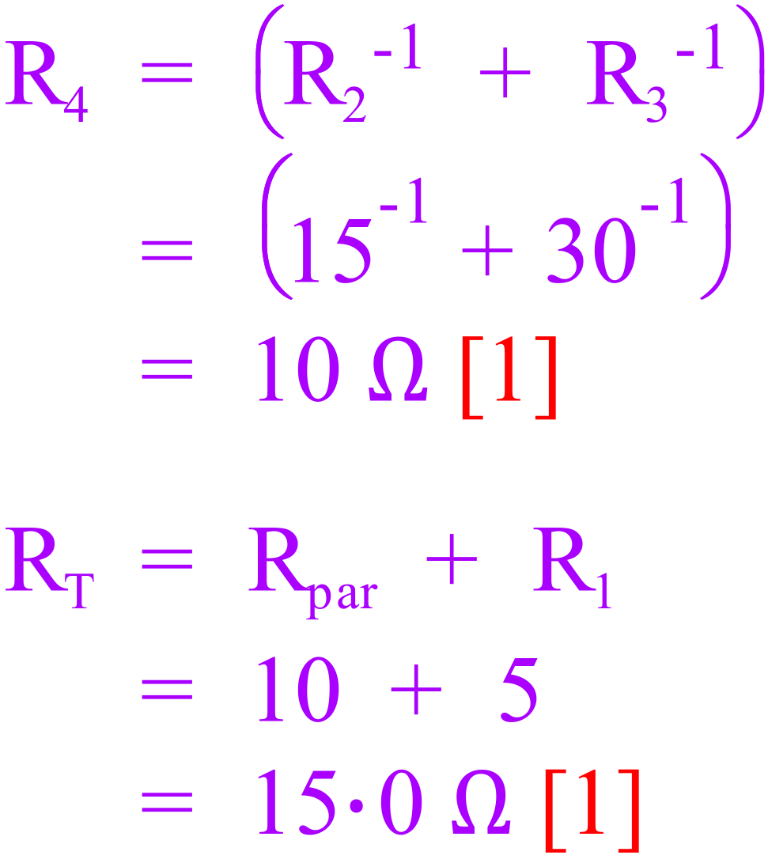

(b) With switches S1, S2 and S3 closed, determine the potential difference across resistors R₁ and R₂ and the battery terminal voltage. (3 marks)

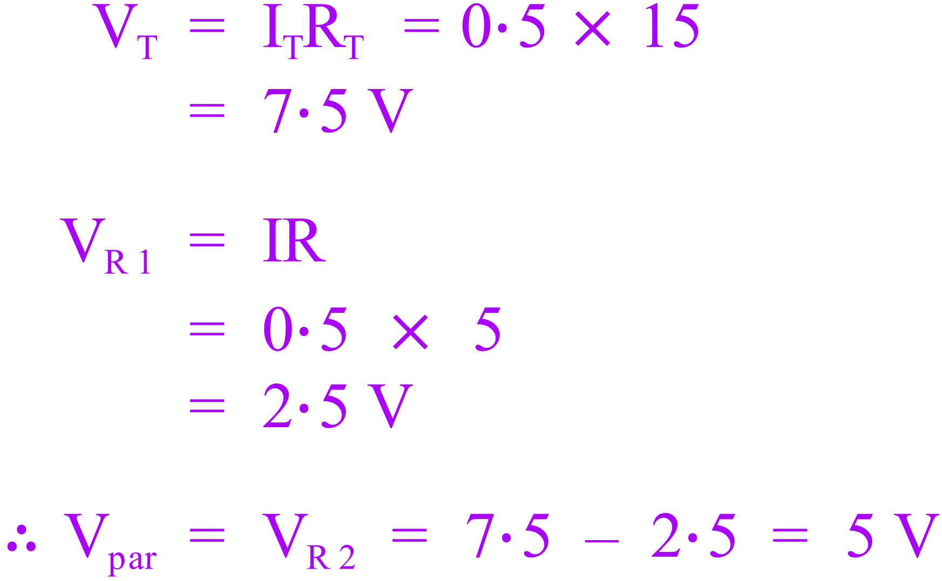
Answer
V_{R1} = 2.50 V
Answer
V_{R2} = 5.00 V
Answer
V_{Batt} = 7.50 V

(c) With switches S1, S2 and S3 closed;

i) Determine the current flowing in the 15.0 Ω resistor. (2 marks)
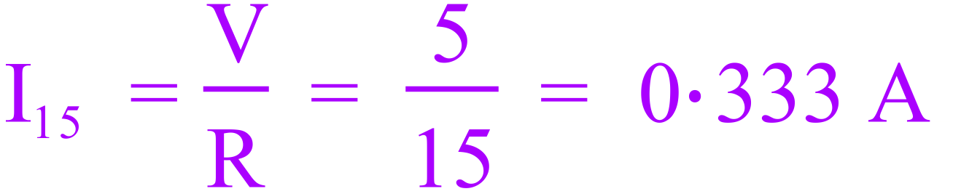

ii) Determine the current flowing in the 30.0 Ω resistor. (1 mark)

(d) With all switches OPEN, what voltage would be measured across R₁? (1 mark)

0
11. An electric circuit which is part of a power tool consists of a battery with 2 identical lamps in series. There is also a fuse in the circuit to protect it. Due to a fault, there is a short circuit (fault) across one of the lamps.
(i) Draw the circuit described above, including the short circuit. Clearly label the short circuit: (2 marks)

Circuit shows components in series [1]

Shows short circuit [1]

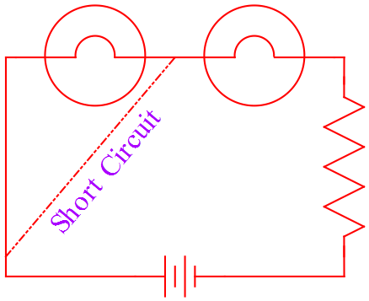

(ii) Prior to the short circuit, both lamps were glowing with the same brightness. Circle one option for each lamp which describes any likely change to its brightness when the short circuit occurs: (2 marks)

a) Short circuited lamp will be: brighter / same brightness / duller / no glow

b) Other lamp will be: brighter / same brightness / duller / no glow

(iii) State one potential danger or negative effect of the short circuit in this situation (1 mark)

- Wire burns out/melts
- Fire
- Causes the globe to blow

(iv) Explain with bullet points how the fuse functions to protect the circuit (2 marks)

- The fuse is designed to break the circuit [1]
if the current exceeds a safe level [1].

☺ CONGRATULATIONS: ☺
YOU HAVE COMPLETED THE FINAL Y11 PHYSICS TEST

